

Computer Games Development CW208

GDD

Year IV

[Adam Mcguigan]

[C00248515]

|  |  |
| --- | --- |
|  |  |
| [Submission Date: 24-04-2023] | |

[Declaration form to be attached]

Contents

Acknowledgements 4

Game Overview 5

Feature Set 5

General Features 5

Multiplayer Features 5

Editor 5

Gameplay 5

The Game World 6

Overview 6

The Physical World 6

Overview 6

Key Locations 6

Travel 6

Scale 6

Objects 6

Weather 6

Day and Night 6

Time 7

Rendering System 8

Overview 8

2D/3D Rendering 8

Camera 8

Overview 8

Camera Detail #1 8

Camera Detail #2 8

Game Engine 9

Overview 9

Game Engine Detail #1 9

Water 9

Collision Detection 9

The World Layout 10

Overview 10

World Layout Detail #1 10

World Layout Detail #2 10

Game Characters 11

Overview 11

Creating a Character 11

Enemies and Monsters 11

User Interface 11

Overview 11

User Interface Detail #1 11

User Interface Detail #2 11

Weapons 12

Overview 12

Weapons Details #1 12

Weapons Details #2 12

Single-Player Game 13

Overview 13

Single Player Game Detail #1 13

Single Player Game Detail #2 13

Story 13

Hours of Gameplay 13

Victory Conditions 13

Character Rendering 15

Overview 15

Character Rendering Detail #1 15

Character Rendering Detail #2 15

World Editing 15

Overview 15

World Editing Detail #1 15

World Editing Detail #2 15

References 16

# Game Overview

In this VR survival game, the player finds themselves stranded in a barren wasteland with a broken-down vehicle. The player must scavenge for various resources such as consumables and ammo. As they explore the wasteland, the player will come across different enemy types, ranging from small weak creatures to powerful bosses. The player must use their wits and whatever weapons they can find to defend themselves against these enemies to stay alive.

The player’s goal is to defeat the boss enemies to collect the vehicle parts, which can be used to repair the players broken down vehicle. The player must gather all vehicle parts to have a chance at repairing the vehicle and escaping the wasteland.

* Screenshots here

# Feature Set

## General Features

Open world map for player to explore.

Multi Behaviour AI Enemies

Destructible environments

3D VR gameplay

32-bit colour

# Acknowledgements

# 

# Game Overview

In this VR survival game, the player finds themselves stranded in a barren wasteland with a broken-down vehicle. The player must scavenge for various resources such as consumables and ammo. As they explore the wasteland, the player will come across different enemy types, ranging from small weak creatures to powerful bosses. The player must use their wits and whatever weapons they can find to defend themselves against these enemies to stay alive.

The player’s goal is to defeat the boss enemies to collect the vehicle parts, which can be used to repair the players broken down vehicle. The player must gather all vehicle parts to have a chance at repairing the vehicle and escaping the wasteland.

* Screenshots here

# Feature Set

## General Features

Open world map for player to explore.

Multi Behaviour AI Enemies

Destructible environments

3D VR gameplay

32-bit colour

# Game Overview

In this VR survival game, the player finds themselves stranded in a barren wasteland with a broken-down vehicle. The player must scavenge for various resources such as consumables and ammo. As they explore the wasteland, the player will come across different enemy types, ranging from small weak creatures to powerful bosses. The player must use their wits and whatever weapons they can find to defend themselves against these enemies to stay alive.

The players ultimate goal is to defeat the boss enemies in order to collect the vehicle parts, which can be used to repair the players broken down vehicle. The player must gather all vehicle parts in order to have a chance at repairing the vehicle and escaping the wasteland.

# 

# Feature Set

## General Features

Open world map for player to explore

Multi Behaviour AI Enemies

Destructible environments

3D VR gameplay

32-bit color

## Gameplay

# The Game World

The world will be large scale so the players can explore with different key locations that they could walk around in. The world will have large mountains and have lots of forest areas to explore. Player will have to explore different areas to scavenge for weapons in order to survive the enemies spread across the world.

## The Physical World

**Starting Area** – Player will be able to take their time here and choose to which kind of movement they would like to use during the game. The player will also be shown their objectives and control scheme for the game here

### Overview

The map will be broken down into smaller sections in which the player will have to traverse.

**Boss Areas**

These areas will be littered with more powerful enemies or one main boss fight. These areas will be more spread-out from each other so that they player will have the chance to replenish health or ammo before heading for the next objective. Each area will have different factors that make it stand out from the rest of the map, e.g. stockpiles of resources, heavier enemy presence etc.

**Village**

In this area of the map, the player will be able to roam around and scavenge various buildings that might contain loot for the player. These areas wont be free of enemies, they player will have to be careful not to alert the enemies while looting.

**Extract**

This is where the broken-down vehicle will be extracted, the player will have to repair the vehicle here in order to escape. The player can come back with each piece individually and repair the vehicle or comeback will all pieces together and repair.

**Wandering Enemy**

As the player explores the map, it wont just be a relaxing time, the player will have to keep their wits about them as they may bump into enemies that are patrolling the map.

### Travel

The player will be able to traverse the map using two kinds of VR movement, they can use the trigger button on their controller to enable a teleportation ray highlighting where they are aiming at or the player will be able to use the joystick on their controller to use Continuous Movement, which would be similar to using the joystick on a regular console controller for movement. The player will be able to toggle between both kinds of movement during the game, as these allows better flexibility while playing.

### Scale

The overall scale of the game is large, I wanted to create something large but not too big so that the player feels like that they’re in a walking simulator for majority of the game. The world edges will also have some boundaries so that the player has some indication of whether they should be in a certain area.

### Objects

There will be various objects used throughout this game for now a quick rundown of what will be in the game range from, Weapons both ranged and melee, Throwables, consumables such as Health kits, ammunition etc. A full list will be provided here once finished.

### Weather

The world will be set in a post-apocalyptic era so, orange hues in the world will help with atmosphere. Weather will be cloudy, dull with atmospheric smog. As the day goes on lightning strikes.

### Time

The game will have day hours go by slower and night faster not to limit the player to their visibility as playing in VR and not being able to see anything wouldn’t give player a good game experience.

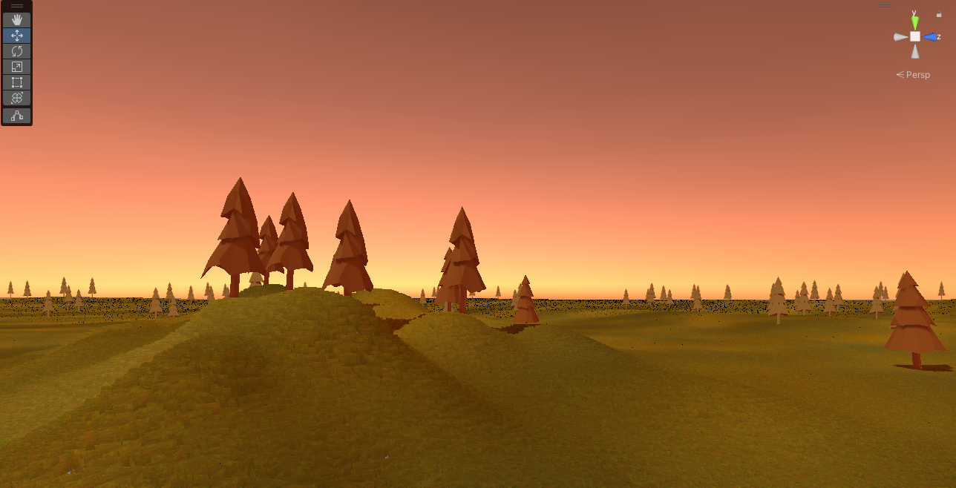

# Rendering System

## Overview

The objects in the world will use LOD and will render with players appropriate positions, for example when players are far away from certain tree, the tree will be rendered in a lower quality in order not to restrain the VR headset.

## 2D/3D Rendering

The game will be made in 3D and most models will be made using low poly technique as rendering those objects wont effect the game much.

Describe what sort of 2D/3D rendering engine will be used.

## Camera

### Overview

The main camera will be attached to the player rig inside the hierarchy of the game. This will allow the player to have that first person view for VR.

### Camera Detail #1

The camera will be able to follow the players rotation of their head in real life. This will allow for a more immersive and natural feel to the game while playing. The player will also be able to use this in conjunction with the other camera rotations via the analogue sticks

### Camera Detail #2

The second way the camera will work is via the right analogue stick on the controller, the player will be able to use this like a console controller and rotate their view using the right stick. The player will have the option of using two kinds of rotation using the stick. 1. Being Snap Rotation – this will move the camera in 45 degree turns, 2. Continuous rotation – like the name suggests, if the player moves the stick to the right the camera will continue to rotate that way.

# Game Engine

## Overview

Unity is a popular game engine used for creating 2D and 3D games. It is a cross platform engine, which means that games developed using Unity can be played on a variety of different platforms, including PC, Mac, Linux, mobiles devices and consoles. Unity has a large and active community of users, who share tips, resources and support each other.

### Game Engine Detail #1

The game engine will keep track of everything in the world like amount of enemies all the way to objects placed in the game world. This is great for item pickups and creating waves of NPCs that might be in the game.

### Collision Detection

Our game engine will manage collision detection in the game between all objects. This can be achieved by using various colliders on different objects. The primary collider that will be used in the game will be a ‘box collider’ as this is the by far the most optimised collider from all the colliders that are available. Despite having custom models for NPCs in the game the, the box collider will be far more useful to use instead of a mesh collider because the more mesh colliders used the bigger the hit on performance in the game.

Unity engine handles collision detection well because it provides robust and flexible collision detection options that can be easily integrated into a game's physics engine. Unity's collision detection system is based on the NVIDIA PhysX physics engine, which allows for accurate and realistic physics simulations. Unity's collision detection methods are also optimized for performance, ensuring that games run smoothly even with complex physics interactions. Additionally, Unity's collider components allow developers to define the shape of an object's collider, enabling more precise collision detection. Overall, Unity's collision detection system provides developers with the tools they need to create immersive and engaging games with realistic physics interactions.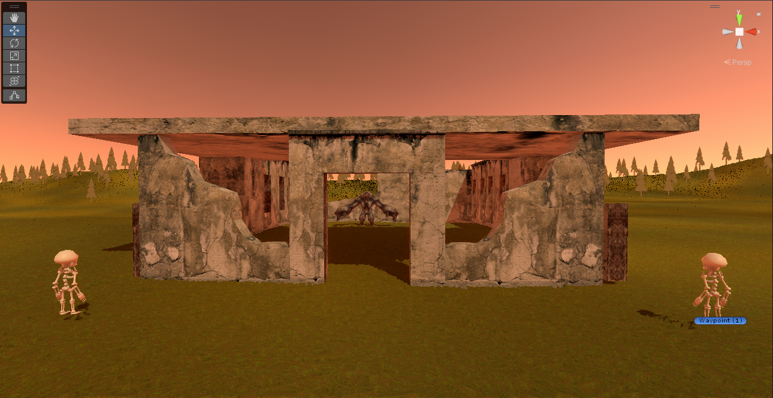

# The World Layout

The world will have different areas in which they player will be able to experience and explore

## Overview

Players will have the opportunity to explore a vast world that features various key locations, ranging from towering mountains to expansive forest areas. The game's day and night cycle will add to the fun and provide players with a diverse range of scenery to experience.

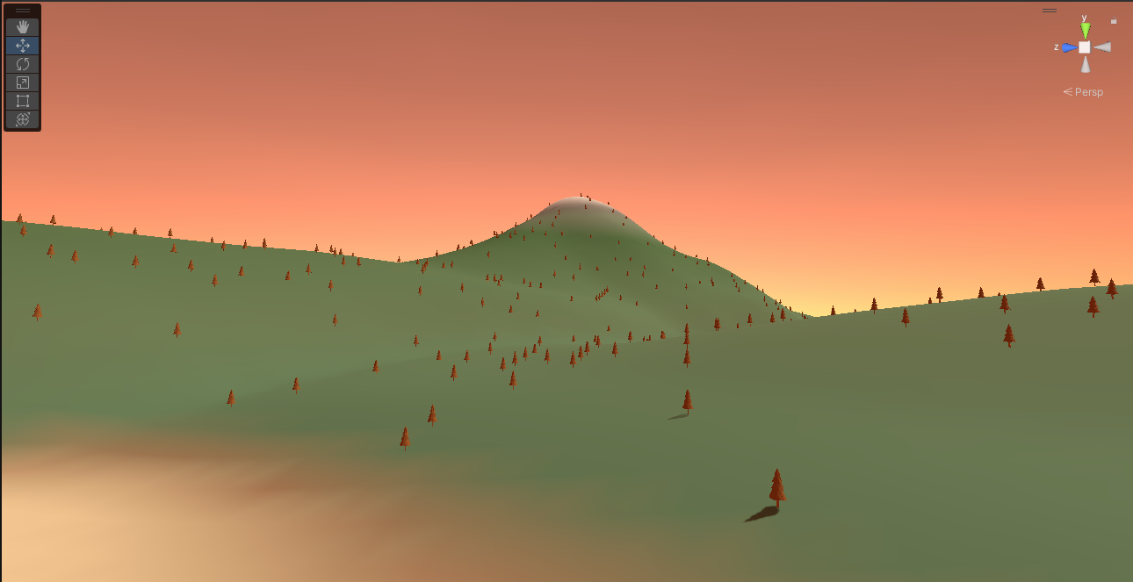

# Game Characters

## Overview

The Player – the only visible piece of the player will be the hand models in game.

NPC – There will be numerous types of NPCs ranging from mutated animals to blood craving humans. Some of the NPCS maybe aggressive straight away to the player while others might give the player a chance to flee first.

## Creating a Character

The personalization of the character will be down to the hand models picked by the player. In the main menu the player will be able to select between three kinds of hand models, the selected hand model will be used for the duration of the game.

## Enemies and Monsters

As stated above, there will be various types of enemies and monsters in the game. There will be mutated wildlife that the player will have to keep an eye out for, while also looking out for the other NPC that will be patrolling the map. As the player progresses to new areas of the map, they will face more and more powerful enemies whose damage will be increased as well as their health. Each boss will be able to summon more less powerful enemies while they try retreat during the fight to heal.

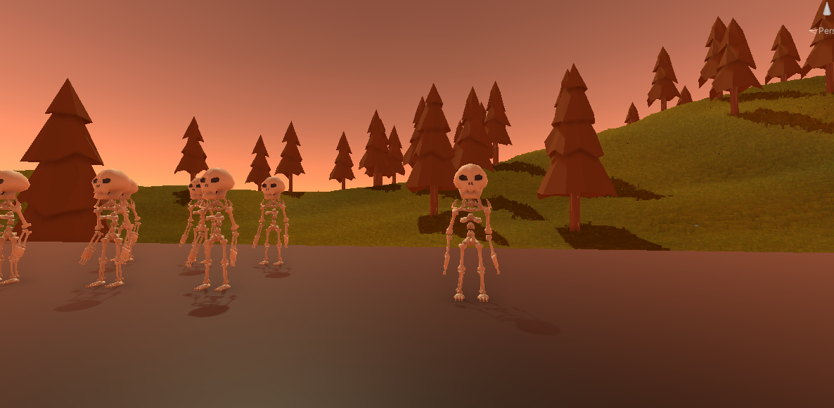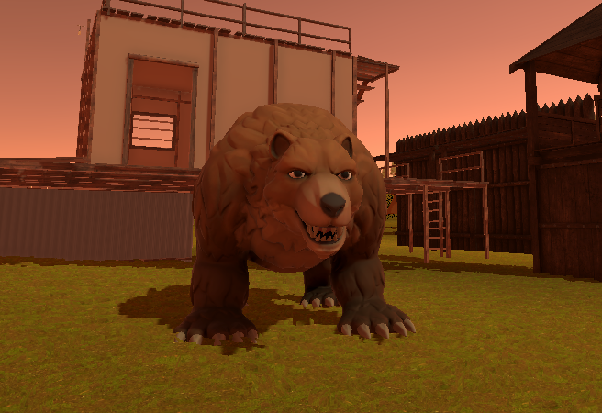

# User Interface

## Overview

The player will be able to pause the game, from here they will be able to go back to the main menu, view options or quit the game entirely. In options the player will have the option to change the volume level as well as the option to change the movement input they are using.

### User Interface Detail #1

As the player moves around, they will have a compass objective that will be displayed on screen that will let the player know of the current location of each of their objectives.

### User Interface Detail #2

There will be a health bar displayed on screen in the lower corner. The player will be able to see this in the headset and it will let them know their current health

# Weapons

There will be a variety of weapons that the player will be able to use during their playthrough of the game.

## Overview

Two weapons that player will be able to use is a pistol and a semi-automatic rifle. Both weapons will have different properties and will handle differently from each other giving them their own unique feel, the code will require a script that can be changed to make any weapon as desired. The players will be able to wield these weapons however they choose. Players will be able to place the weapons in both hands or they can use both hands on weapons wherever there is enough room to do so.

### Weapons Details #1

The first weapon that the player will come across will be the pistol. This weapon will deal significantly less damage than the rifle shown in the example below. The idea of this was to allow the play to have one gun in which they can rely on, no matter what situation they get into.

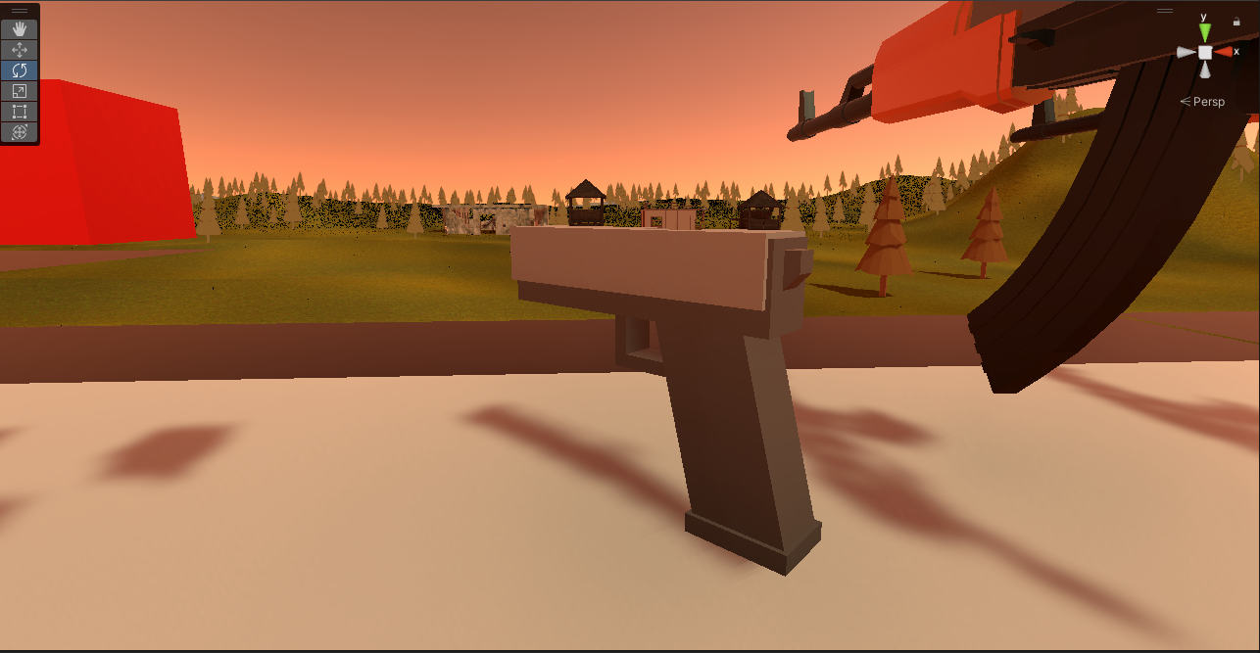

### Weapons Details #2

The second weapon the player will come across will be a makeshift semi-automatic rifle. This rifle will have more recoil than the pistol and will have more spread which will make it less reliable at range.

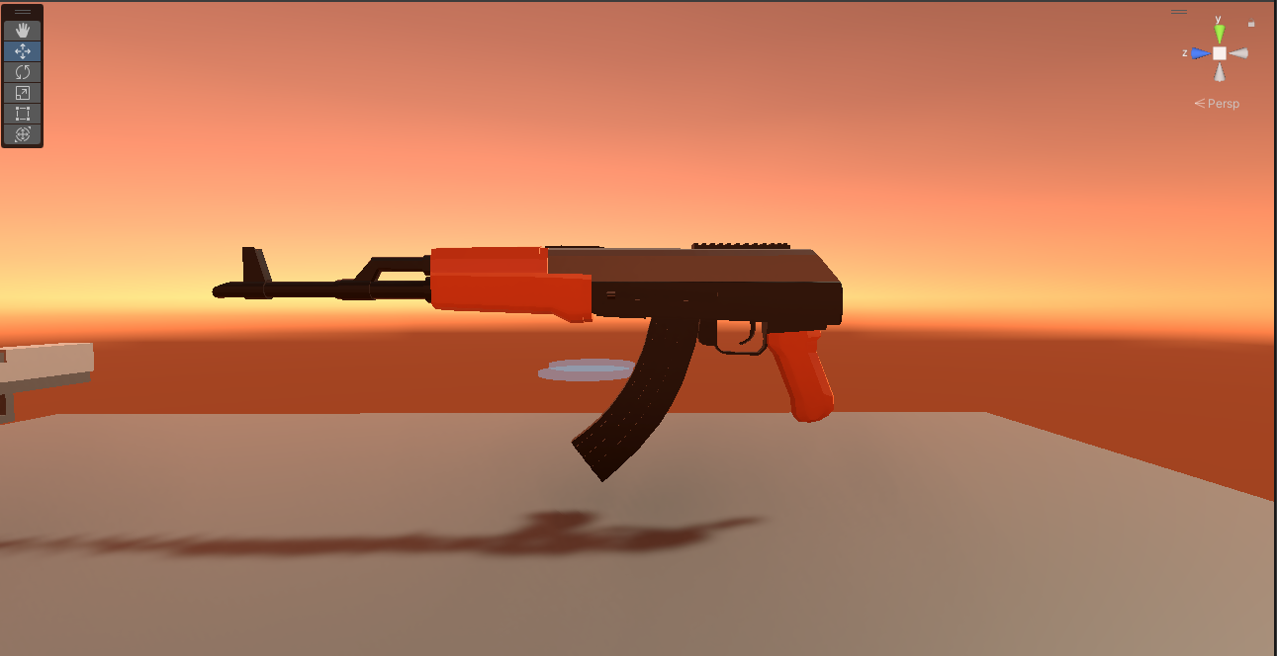Single-Player Game

## Overview

The player will spawn in a baron wasteland with little resources on them. Player will have to navigate their way around the map collecting weapons and resources while avoiding the dangerous enemies that are roaming around.

### Single Player Game Detail #1

One feature that will be clearly evident and quite useful for the player will be the inventory system. The inventory system has been redesigned in this game and is different to most inventory systems out there. The player will have two small wrist pockets that will allow them to store valuable items that they will need while playing.

The player will have a choice of what kind of items they wish to carry with them, they can prioritise carrying objective items in their wrist pockets or they can choose to just carry healing items with them. The main goal was to allow the player to choose what they wanted to place inside.

### Single Player Game Detail #2

The second feature that will be displayed in the single player gameplay is the strongholds that they player will need to clear out to complete their objectives. The player will need to gear up and travel to various strongholds that will have enemy bosses inside. The player will need to defeat the bosses in order to collect objective items to bring back to the starting area to repair their broken-down vehicle.

Each stronghold will hold its own boss, that will be unique from every other boss in the game. Each boss will have their own attacks and will behave differently when they take damage. Some may charge the player when their health dips below a certain threshold or they may retreat and summon grunt enemies to fight while they regenerate their health. The player will need to be careful when visiting these locations if they don’t have the right firepower.

### Story

The player must scavenge for various resources such as consumables and ammo. As they explore the wasteland, the player will come across different enemy types, ranging from small weak creatures to powerful bosses. The player must use their wits and whatever weapons they can find to defend themselves against these enemies to stay alive.

The players ultimate goal is to defeat the boss enemies in order to collect the vehicle parts, which can be used to repair the players broken down vehicle. The player must gather all vehicle parts to have a chance at repairing the vehicle and escaping the wasteland.

### Hours of Gameplay

There will be replay ability in this game, each time that the game is started a random map is generated which means that the player should not be able to speed run the game and complete it in a quick manner. Each playthrough should last a reasonable length of time.

### Victory Conditions

The player will be able to complete and win the game if they manage to repair their getaway vehicle from defeating all bosses and clearing the strongholds in the map. If the player fails to do so, the player will have to restart the game again. This is a hardcore world which means there is no respawns!

# Character Rendering

## Overview

There is not much to render with this project for the players character model. The only thing being rendered for the player will be the hand models. Unity will be handling the rendering of all characters in this game, which is a benefit of using Unity and the technology it has built in.

# References

* Unity XR Input, Unity Technologies (2023) [Online] Available at: <https://docs.unity3d.com/Manual/xr_input.html> (Accessed:24-04-2023)
* Input for OpenVR controllers, Unity Technologies (2023) [Online] Available at: <https://docs.unity3d.com/560/Documentation/Manual/OpenVRControllers.html> (Accessed:24-04-2023)
* William, How to Perform VR Interaction With Objects [Unity Tutorial] (2023) [Online]Available at: <https://arvrtips.com/vr-interaction-with-objects/> (Accessed:24-04-2023)
* Green Hell VR on Steam (2023) [Online] Available at: <https://store.steampowered.com/app/1782330/Green_Hell_VR/> (Accessed:24-04-2023)
* Into The Radius (VR), Steam (2022) [Online] Available at: [Into The Radius](https://store.steampowered.com/app/1012790/Into_the_Radius_VR/) (Accessed:22-04-2023)